

**CISB5123 Text Analytics**

**Lab 4**

**Basic Text Pre-processing**

Text pre-processing is a process to clean and prepare the textual data before they can be used as the input for text modelling techniques.

It consists of breaking down the **documents** in **corpus** into **tokens**.

**The steps in text pre-processing in Python**

1. Read the source data
2. Remove punctuations and standardize words into lowercases in the documents using **string** library
3. Remove numbers using **re.sub ( )** in **regular expression** library
4. Break down the words in documents into tokens using **nltk** library
5. Remove stopwords using **nltk** library
6. Perform word stemming using **Porter Stemmer** in **nltk** library
7. Perform word lemmatization using **WordNetLemmatizer( )** in **nltk** library

**Step 1: Read the source data**

*#import pandas module for creating dataframe*

**import** pandas **as** pd

*#read CSV into DataFrame*

data = pd.read_csv("Review.csv")

data

**Step 2: Remove punctuations and standardize words into lowercases in the documents using string library**

*#import string module for string manipulation*

**import** string

*#The constant in string module to remove punctuations*

string.punctuation



*#defining the function to remove punctuations in the documents*

**def** remove_punctuation(text):

*# Initialize an empty string to store the result*

punctuation_free = ""

*# Iterate over each character in the text*

**for** i **in** text:

*# Check if the character is not in the string.punctuation set*

**if** i **not in** string.punctuation:

*# If not, add the character to the result string*

punctuation_free += i

**return** punctuation_free

*#applying the remove_punctuation function to the 'Review' column and storing the result in a new column 'clean_punctuation'*

data['clean_punctuation']= data['Review'].apply(remove_punctuation)

data

*#to standardize the cases in the documents into lower case*

data['clean_lower']= data['clean_punctuation'].str.lower()

data



**Step 3: Remove numbers using re.sub ( ) in regular expression library**

*#import regular expression library*

**import** re

*#function to remove digit (\d) or hypens (-) from the documents with an empty string ''*

**def** remove_numbers(text):

**return** re.sub("[\d-]",'',text)

*#applying the remove_numbers function to the 'clean_lower' column and storing the result in a new column 'clean_number'*

data['clean_number'] = data['clean_lower'].apply(remove_numbers)

data

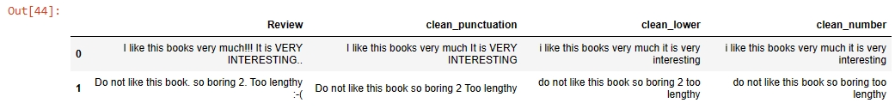

**Step 4: Break down the words in documents into tokens using nltk library**

*#import Natural Language Processing (NLP) library called*

*#Natural Language Toolkit (NLTK)*

**import** nltk

nltk.download('punkt')

*# import the library for word tokenization*

**from** nltk.tokenize **import** word_tokenize

*#the word tokens in the document*

data['token_data']**=** data['clean_number'].apply(word_tokenize)

data

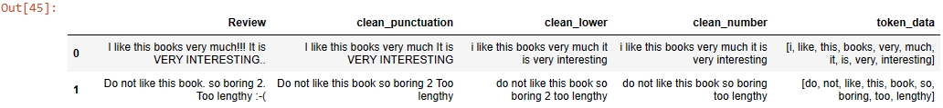

**Step 5: Remove stopwords using nltk library**

*#download stopwords*

nltk.download('stopwords')

*#Get the list of English stop words present in the library*

stopwords **=** nltk.corpus.stopwords.words('english')

*# Print the list of stopwords*

print(stopwords)

*#defining the function to remove stopwords from tokenized text*

**def** remove_stopwords(text):

output = []

**for** i **in** text:

**if** i **not in** stopwords:

output.append(i)

**return** output

*#Applying the remove_stopwords function to the 'token_data' column and storing the result in a new column 'clean_xstopwords'*

data['clean_xstopwords'] = data['token_data'].apply(remove_stopwords)

data

**Step 6: Perform word stemming using Porter Stemmer in nltk library**

*#importing the Stemming function from nltk library*

**from** nltk.stem.porter **import** PorterStemmer

*#defining the object for stemming*

porter_stemmer **=** PorterStemmer()

*#defining a function for stemming*

**def** stemming(text):

stem_text = []

**for** word **in** text:

stemmed_word = porter_stemmer.stem(word)

stem_text.append(stemmed_word)

**return** stem_text

*#applying the stemming function to the 'clean_xstopwords' column and storing the result in a new column 'clean_stemmed'*

data['clean_stemmed'] **=** data['clean_xstopwords'].apply(stemming)

data

**Step 7: Perform word lemmatization using WordNetLemmatizer( ) in nltk library**

nltk.download('wordnet')

*#importing the Lemmatizer function from nltk library*

**from** nltk.stem **import** WordNetLemmatizer

*#defining the object for Lemmatization*

wordnet_lemmatizer **=** WordNetLemmatizer()

*#defining the function for lemmatization*

**def** lemmatizer(text):

lemm_text = []

**for** word **in** text:

lemmatized_word = wordnet_lemmatizer.lemmatize(word)

lemm_text.append(lemmatized_word)

**return** lemm_text

*#* *#applying the lemmatizer function to the 'clean_xstopwords' column and storing the result in a new column 'clean_lemmatized1'*

data['clean_lemmatized1']**=**data['clean_xstopwords'].apply(lemmatizer)

*#* *#applying the lemmatizer function to the 'clean_stemmed' column and storing the result in a new column 'clean_lemmatized2'*

data['clean_lemmatized2']**=**data['clean_stemmed'].apply(lemmatizer)

data

